**Riphah International University**



**Alisha Ishrat**

**40851**

**CS-6**

**Operating System**

**Lab 5**

**Task 1:**

1. The time of the log entry in the 12-hour format with AM/PM format.

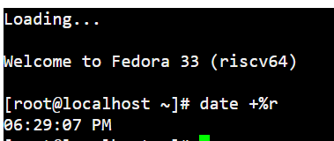

1. The date of the log entry in “Month Date Year” format.

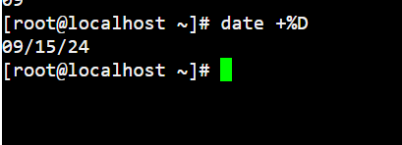

1. The full weekly name of the log entry.

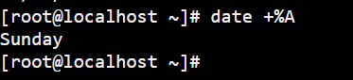

1. The numerical representation of the month.



1. The last two digits of the year.

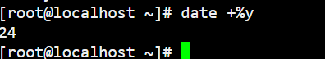

**Task 2:**

Command used to display current time in hours-minutes.



Another method form which we achieve same result.

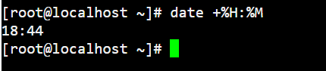

**Task 3:**

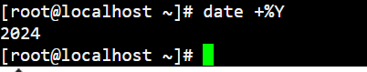

**Task 4:**

Numerical representation of day month year and time.

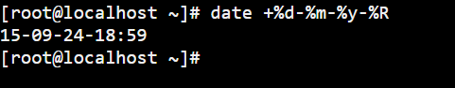

**Task 5:**

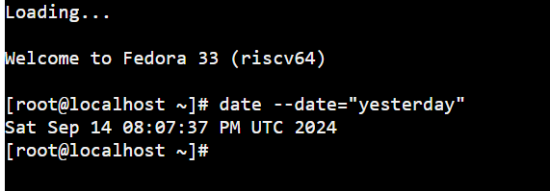

**Task 6:**

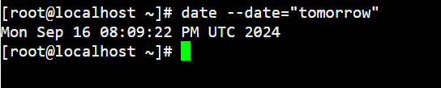

**Task 7:**

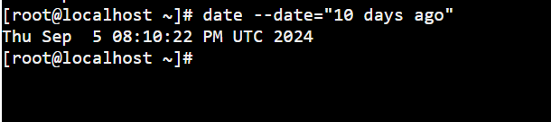

**Task 8:**

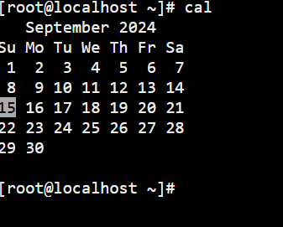

**Task 9:**

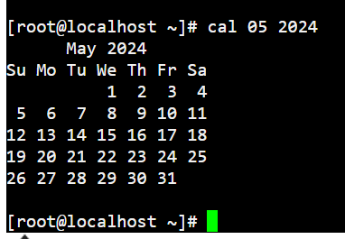

**Task 10:**

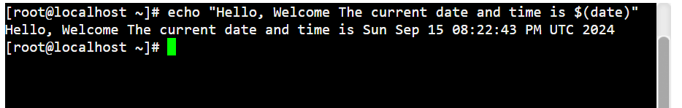

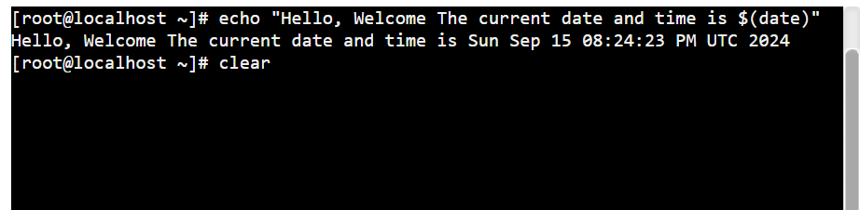

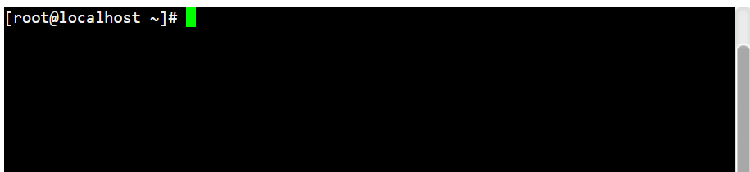

**Task 11:**

Create a file named data.txt and add strings in the file.

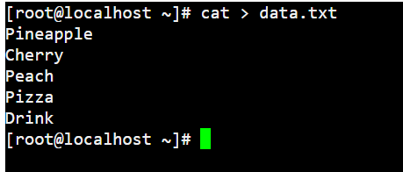

Now, sorting the strings in reverse order.

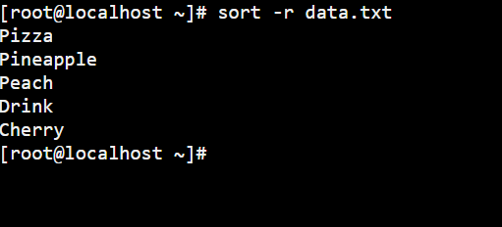

**Part (B)**

